**HW2 Report**

* **Task 2:**

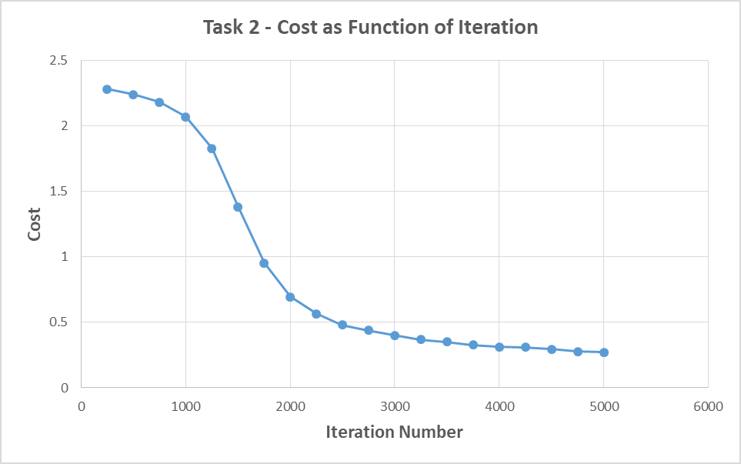Test Set Accuracy: 92.6%

|  |  |
| --- | --- |
| **Iteration** | **Cost** |
| 250 | 2.278 |
| 500 | 2.239 |
| 750 | 2.179 |
| 1000 | 2.067 |
| 1250 | 1.827 |
| 1500 | 1.382 |
| 1750 | 0.952 |
| 2000 | 0.695 |
| 2250 | 0.566 |
| 2500 | 0.48 |
| 2750 | 0.44 |
| 3000 | 0.399 |
| 3250 | 0.369 |
| 3500 | 0.35 |
| 3750 | 0.328 |
| 4000 | 0.311 |
| 4250 | 0.31 |
| 4500 | 0.294 |
| 4750 | 0.276 |
| 5000 | 0.27 |

* **Task 3:**

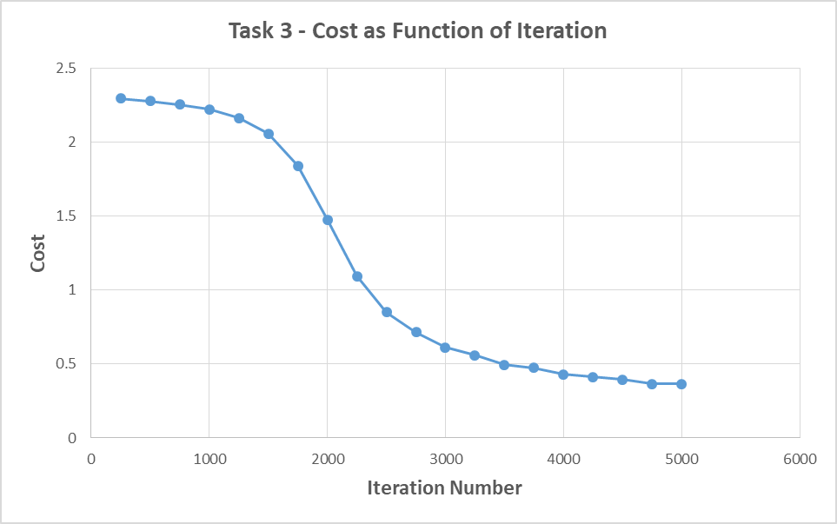Test Set Accuracy: 91.76%

|  |  |
| --- | --- |
| **Iteration** | **Cost** |
| 250 | 2.293 |
| 500 | 2.275 |
| 750 | 2.252 |
| 1000 | 2.219 |
| 1250 | 2.161 |
| 1500 | 2.055 |
| 1750 | 1.838 |
| 2000 | 1.475 |
| 2250 | 1.094 |
| 2500 | 0.848 |
| 2750 | 0.714 |
| 3000 | 0.613 |
| 3250 | 0.558 |
| 3500 | 0.495 |
| 3750 | 0.473 |
| 4000 | 0.43 |
| 4250 | 0.413 |
| 4500 | 0.394 |
| 4750 | 0.366 |
| 5000 | 0.366 |

* **Task 4:**

Early stop after: **36** iterations

Validation Set Accuracy: 8.49%

Test Set Accuracy: 8.33%

* **Task 5a:**

Early stop after: **79** iterations

Validation Set Accuracy: 15.39%

Test Set Accuracy: 15.8%

* **Task 5b:**

Early stop after: **53** iterations

Validation Set Accuracy: 94.725%

Test Set Accuracy: 95.15%

* **Task 6:**

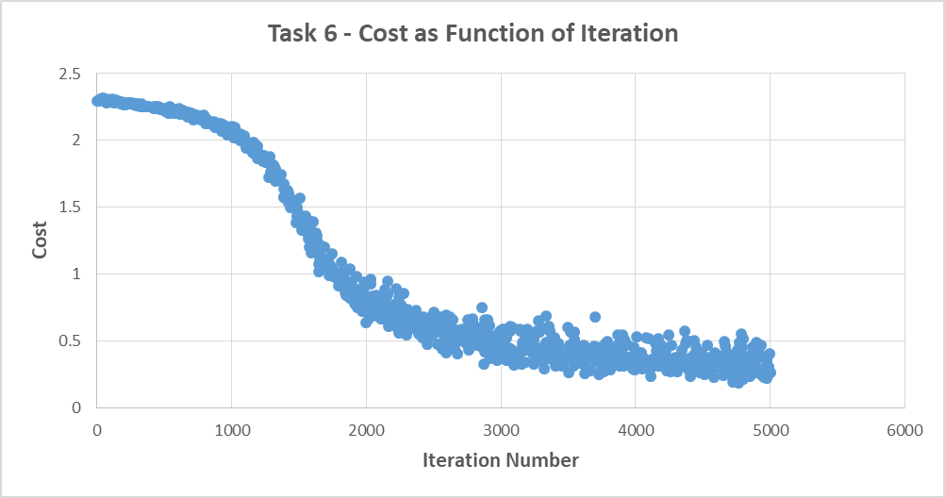Test Set Accuracy: 92.1%

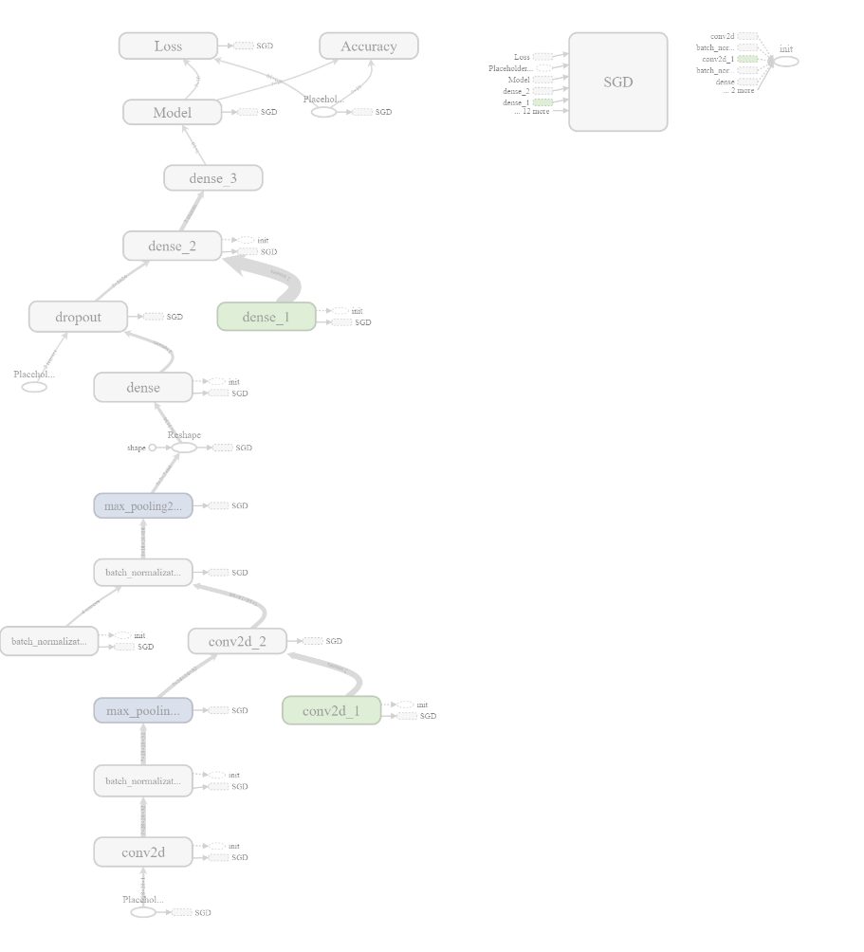Model Graph: